Power Shell 101

**Module 2 Hands-on Activity – PowerShell in VSCode**

4/20/2019 Developed by Sion Yoon

4/20/2019 Tested by Sam Chung

Center for Information Assurance (CIAE) at City University of Seattle

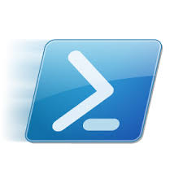

**Learning Outcomes**

* Learn about cmdlet, alias, and PSDrives in PowerShell.
* Learn how to map a new PSDrive

**Resources**

* Cmdlet Overview  
  <https://docs.microsoft.com/en-us/powershell/developer/cmdlet/cmdlet-overview>
* About Providers  
  <https://docs.microsoft.com/en-us/powershell/module/microsoft.powershell.core/about/about_providers?view=powershell-6>
* <https://www.youtube.com/watch?v=_AiTBoH4IwA>

**Activities**

* Using cmdlet
* Using alias
* Mapping PSDrives
* Q&A

**Cmdlet**

1. Open PowerShell in VSCode
2. Cmdlets are lightweight PowerShell scripts that perform a single function. PowerShell uses a verb-noun name pair to name cmdlets. For example, type “get-location”

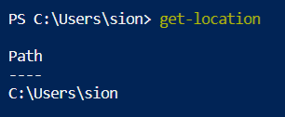

1. “get-help” can be used to learn more about the command. To learn about the get-location cmdlet, type “get-help get-location” or “help get-location”.

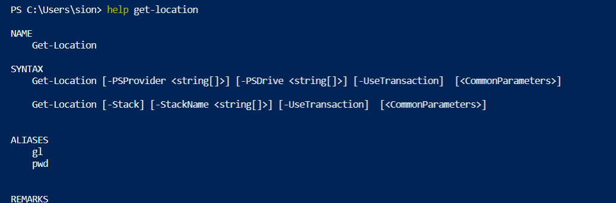

**Alias**

1. Alias are shortcuts or alternate names for cmdlets. Use aliases when you do not want to type the verb-noun format. To get a list of aliases, type “get-alias” or “gal”. Notice that many UNIX commands (“ls”, “cd”, etc.) are set up as aliases by default.

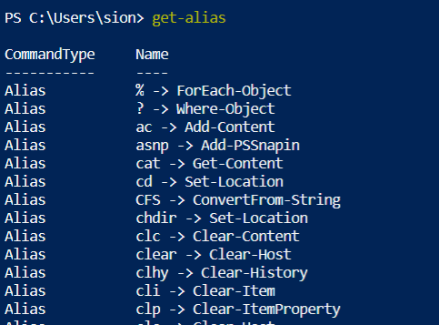

1. To get a list of aliases that start with the letter c, type “gal c*”

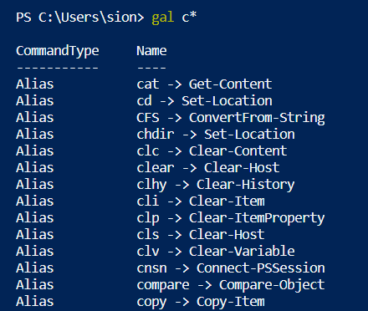

1. You can use an alias, and it works the same as the cmdlet that it references. Type “Clear-Host” or “clear” or “cls”.



**Mapping PSDrives**

1. PowerShell providers connect different forms of storage to PowerShell and make the forms of storage look like a file system. The providers provide access to data and components that would not be easily accessible at the command line. Type “get-psdrive” to see the list of providers.

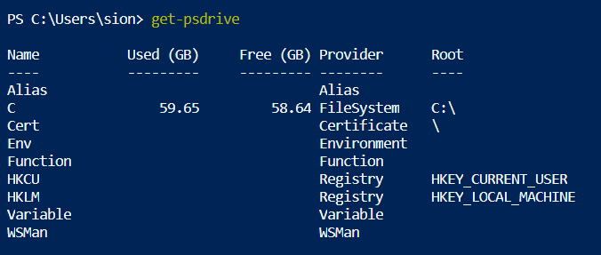

1. To map a new drive, let’s start by creating a folder named ‘test’. Type “mkdir test”

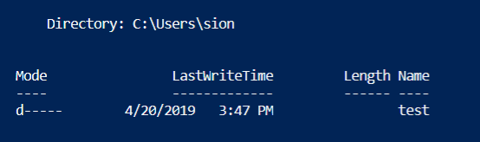

1. To learn how to map a new drive, type “help new-psdrive”. 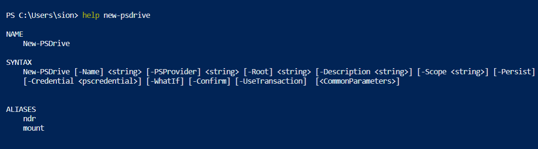
2. If you look at the syntax, you will see that you can map a new drive by typing   
   “new-psdrive test filesystem c:\users\sion\test” for my case.   
   You will need to input your root path.

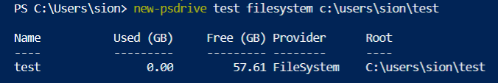

1. To go the test drive that you just created, type “cd test:”  
   
2. Let’s go back to the psdrive to check if the new drive is there.   
   Type, “get-psdrive”.   
   Remember this is a psdrive and only exist within PowerShell.  
   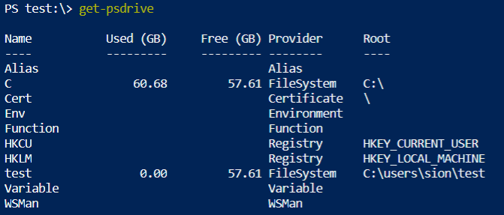
3. Now if you go back to the c drive, type “cd c:”  
   
4. Let’s now undo what we have done by typing “remove-psdrive test”



1. Go back to your psdrive again to check if the drive has been removed   
   by typing “get-psdrive”

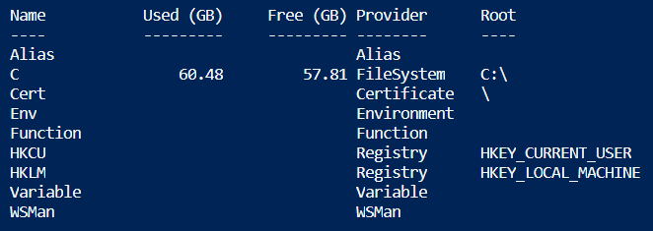

1. Remove the test folder by typing “rmdir test”



**Q&A**

Justify your answers with at least one reference, then export this file to PDF version

1. List out five cmdlets that you would use often and describe the function for each cmdlet.

Get-Help is useful since it acts like a reference.

ForEach-Object seems useful for processing multiple items.

Clear-Content and other cmdlets that are used in creating, writing, reading, deleting files and folders are useful.

Compare-Object is useful for computing.

ConverFrom-StringData is again useful for computing.

<https://stackify.com/powershell-commands-every-developer-should-know/>

1. What would happen if you map a new PSDrive just as you have done in our activity and close your PowerShell session? Is the PSDrive persistent or non-persistent?  
   If non-persistent, what would you do to make it persistent?

The PSDrive is persistent.

PUSH YOUR WORK TO GITHUB

Once you completed the Hands-on practice, do the following to push your work to GitHub

Open the terminal from the VSCode by hitting the control + ~ key, make sure you are in the right path, for example: KimNguyen/Desktop/ISEC505/HOP02-KimNguyenMai/Module 2

Type the following command:

>>> **git add .** (to copy all changes you have made)

>>> **git commit -m “Submission for Module 2 – YOUR GITHUB USERNAME”** (To add a message to your submission)

>>> **git push origin master** (to upload your work to Github)